Instruction:
- What is flip flop? Describe the working mechanism RS flip flop.
Answer:
Flip Flop is a sequential circuit which can remember 1 bit. It is the fundamental unit of memory. It is made by using two nor gates whose output are sent to other nor gate as input which is called a latch (memory latch). When it is combined with synchronous clock of CPU, it is called a flip flop.
A R S Flip Flop contains 2 inputs Reset(R) and Set(S) and two outputs Q and Q’ where Q is the value stored by the flip flop and Q’ is its complement. In the flip flop, the set input is equal to the Q output and the Reset is equal to the Q’. When the reset input is high, the set is low and vice versa. The state of both low results the output Q to be previous output or the stored bit. The state of both high is avoided as it conflicts with the circuit.

When the Reset input is turned high, the stored bit(Q) is set to 0. And it will store the 0 state. Similarly, when the set input is high, the stored bit(Q) is set to 1 and it will continue to output 1 even after the set is again low. This phenomenon is shown with the help of LogSim simulator below:
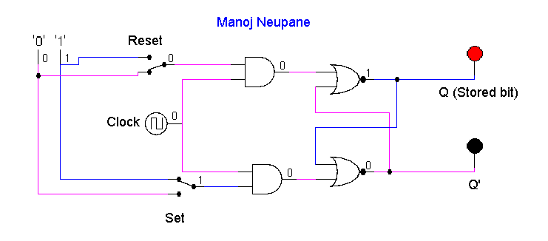
Figure 1
Here in Figure 1, when set is hight, the output Q is high.
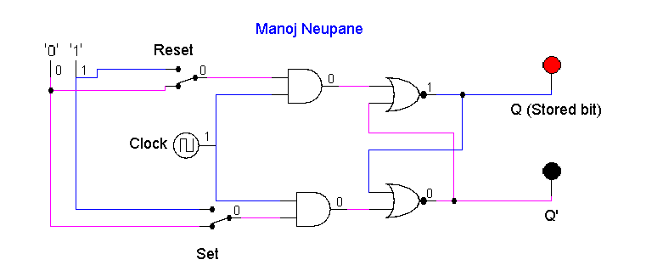
Figure 2
Even when the set is low, the circuit is remembering the high state.
- Construct the timing diagram for half adder and half subtractor, full adder.
Half Adder:
A | B | Sum (A XOR B) | Carry (A.B)
1 | 1 | 0 | 1
1 | 0 | 1 | 0
0 | 1 | 1 | 0
0 | 0 | 0 | 0
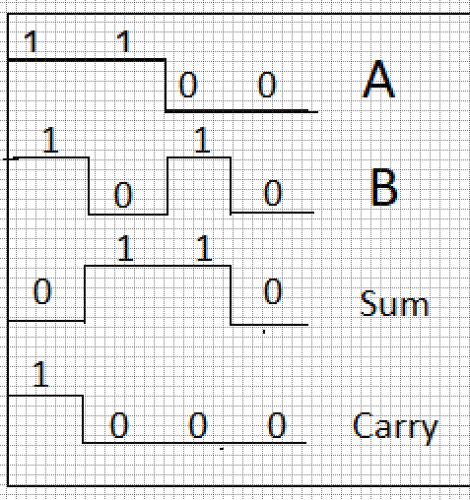

Half Subtractor:
A | B | Sum (A XOR B) | Carry (A’. B)
1 | 1 | 0 | 0
1 | 0 | 1 | 0
0 | 1 | 1 | 1
0 | 0 | 0 | 0

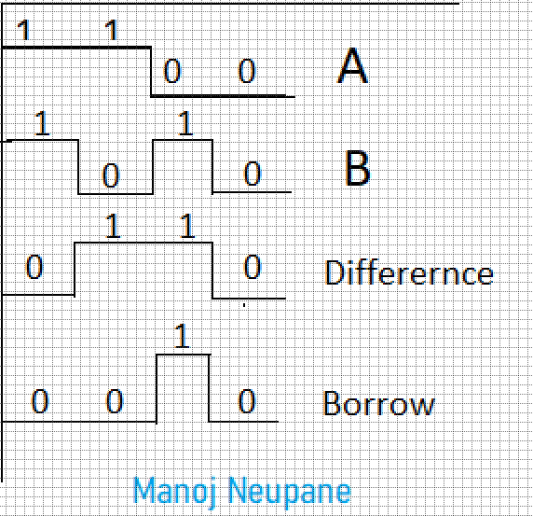

Full Adder:
A | B | C.in | Sum | Carry
1 | 1 | 1 | 1 | 1
1 | 1 | 0 | 0 | 1
1 | 0 | 1 | 0 | 1
1 | 0 | 0 | 1 | 0
0 | 1 | 1 | 0 | 1
0 | 1 | 0 | 1 | 0
0 | 0 | 1 | 1 | 0
0 | 0 | 0 | 0 | 0

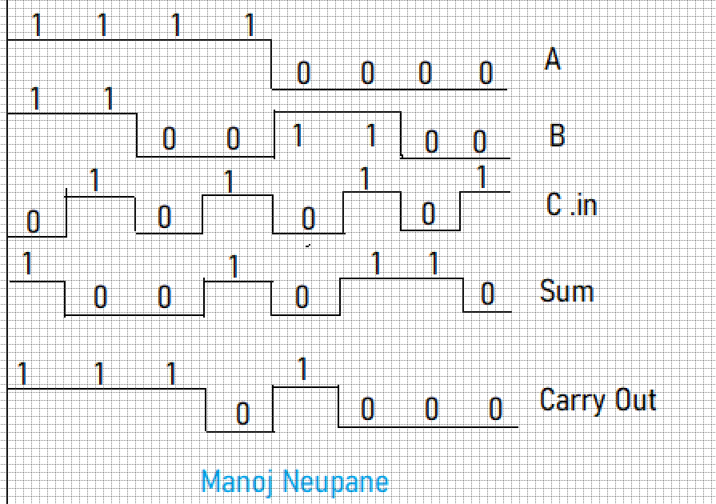

- Describe the working mechanism of 4-bit register by constructing the circuit using D flip flop.
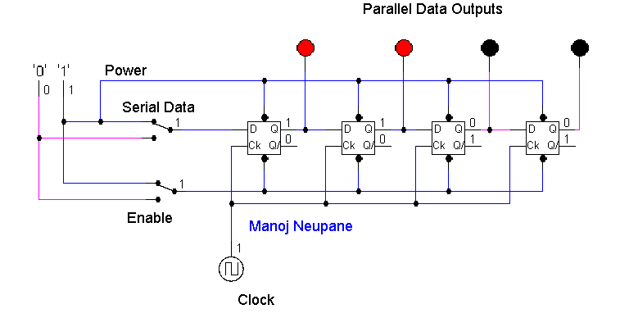

- Differentiate between:
- Flip flop and Latch
Differences:
    - Latch is not synchronous like Flip Flop.
    - Latch is not connected to CPU clock whereas the flip flop is the latch connected with CPU clock.
    - Latch cannot be used practically, and Flip Flop is a practically applicable version of the Latch.
    - Flip Flop requires more power because of the additional clock input.

- Combinational circuit and Sequential circuit
Differences:
    - Combinational Circuits don’t remember previous outputs like Sequential.
    - Combinational Circuits are used for calculations without memory whereas Sequential circuits are used in the logics where memory is required.
    - Sequential Circuits require to be powered all the time to function, whereas the Combinational circuits can be powered only when used.
    - The output of Combinational circuit is based on the inputs passed but in sequential circuit, the output depends on the input as well as the previous outputs.

- SIPO and PISO shift register
Differences:
    - SIPO stands for Serial in Parallel Out and PISO stands for Parallel in Serial Out.
    - As the names suggests, SIPO convers serial data to parallel data and the PISO converts parallel to serial data.
    - SIPO is used to read data from input devices and PISO is used to send/output data to output devices.

